**Assignment No.06**

**Name: -** Omprakash Khaswhi

**\*\*\*\*\*\*\*\*\*\*\*\*\*\*\*\*\*\*\*\*\*\*\*\*\*\*\*\*\*\*\*\*\*\*\*\*\*\*\*\*\*\*\*\*\*\*\*\*\*\*\*\*\*\*\*\*\*\*\*\*\*\*\*\*\*\*\*\*\*\*\*\*\*\*\***

**USE CASE 1: - Check Employee is Present or Absent - Use ((RANDOM)) for Attendance Check**

**Code: -**

echo "Welcome"

ispresent=1

randomcheck=$((RANDOM%2))

if [[ $ispresent -eq $randomcheck ]]

then

echo "Employee is Present"

else

echo "Employee is Absent"

fi

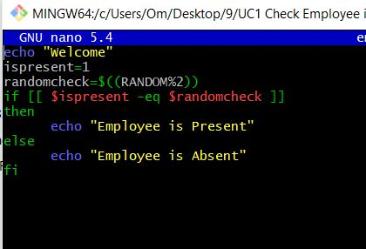

**Output: - 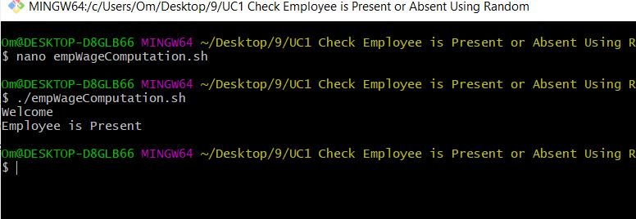USE CASE 2: - Calculate Daily Employee Wage - Assume Wage per Hour is 20 - Assume Full Day Hour is 8**

**Code: -**

echo "Welcome"

IS_FULL_TIME=1

EMP_RATE_PER_HOUR=20

randomcheck=$((RANDOM%2))

if [ $IS_FULL_TIME -eq $randomcheck ]

then

emphrs=8

else

emphrs=4

fi

salary=$(( $emphrs * $EMP_RATE_PER_HOUR ))

echo "Employee Daily Wage is :- " $salary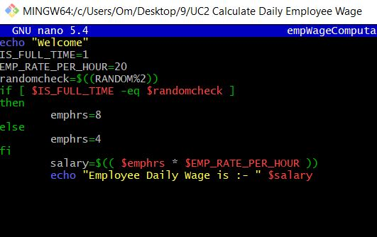

**Output: -**

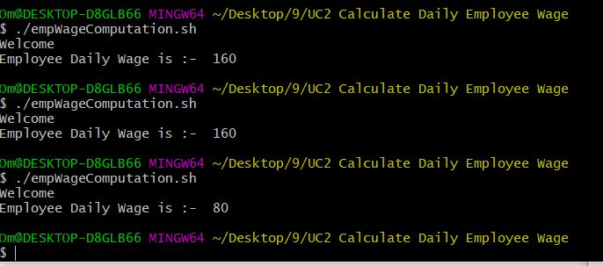

**USE CASE 3: - Add Part time Employee & Wage - Assume Part time Hour is 8**

**Code: -**

echo "Welcome"

isfulltime=2

ispartime=1

EMP_RATE_PER_HRS=20

empcheck=$((RANDOM%2))

case $empcheck in

$isfulltime)

emphrs=8

;;

$ispartime)

emphrs=4

;;

*)

emphrs=0

;;

esac

salary=$(( $emphrs * $EMP_RATE_PER_HRS ))

echo "Part Time Employee Wage :- "$salary

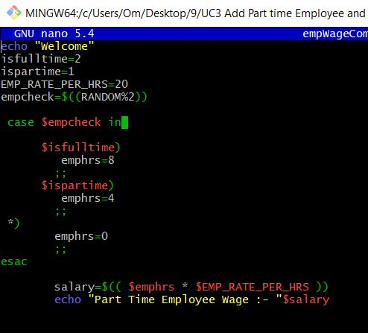

**Output: -**

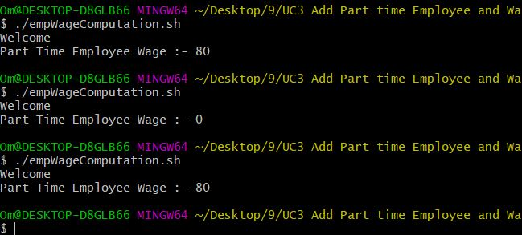

**USE CASE 4: - Solving using Switch Case Statement**

**Code: -**

echo "Welcome"

isfulltime=2

ispartime=1

EMP_RATE_PER_HRS=20

TOTALSALARY=0

NUM_OF_WORKING_DAYS=20

for (( day=1; day<=$NUM_OF_WORKING_DAYS; day++ ))

do

empcheck=$((RANDOM%2))

case $empcheck in

$isfulltime)

emphrs=8

;;

$ispartime)

emphrs=4

;;

*)

emphrs=0

;;

esac

salary=$(( $emphrs * $EMP_RATE_PER_HRS ))

echo $salary

TOTALSALARY=$(( $TOTALSALARY+$salary ))

Done

echo "Part Time Employee Wage Total Sallary :- $TOTALSALARY”

"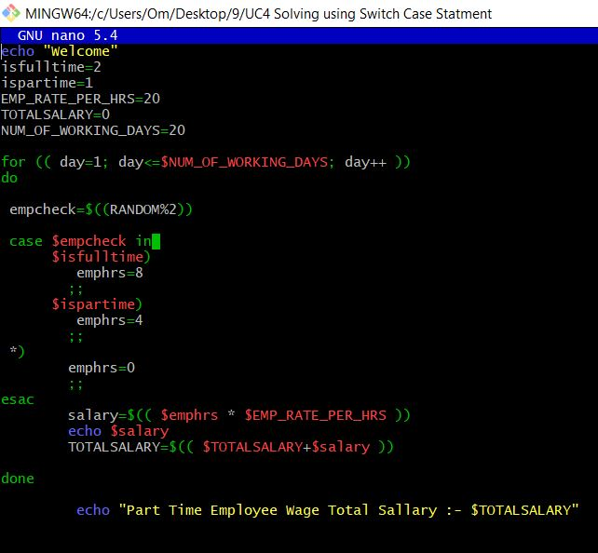

**Output :-** 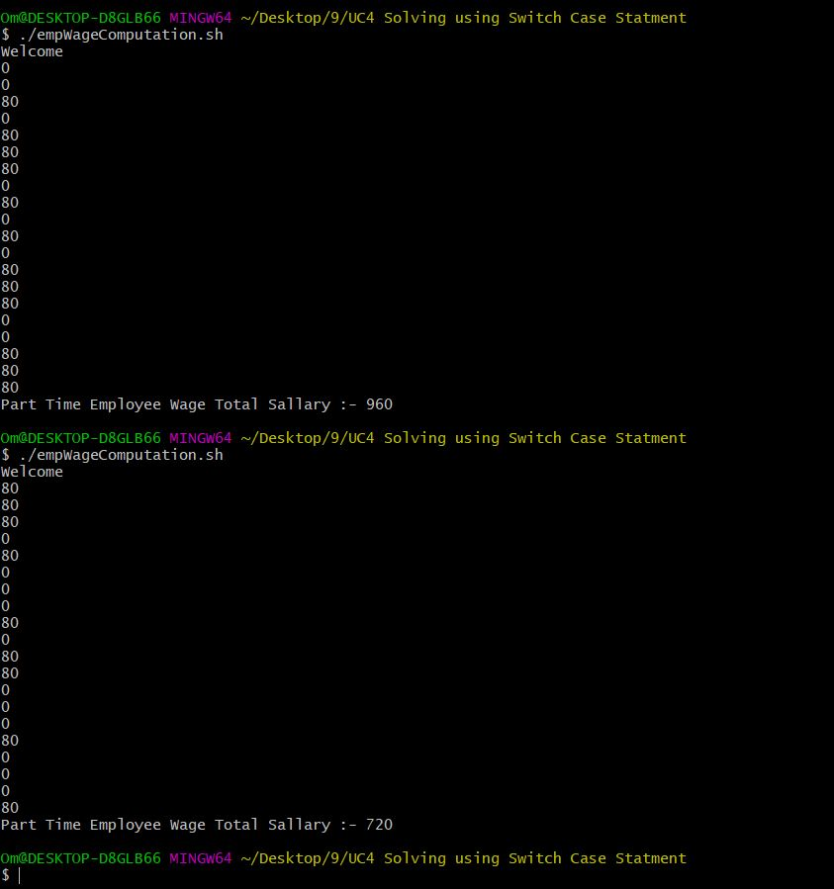

**USE CASE 5: - Calculating Wages for a Month - Assume 20 Working Day per Month**

**Code: -**

echo "Welcome"

isfulltime=2

ispartime=1

EMP_RATE_PER_HRS=20

TOTAL_EMPWAGE=0

TOTAL_EMPHRS=0

NUM_OF_WORKING_DAYS=20

MAX_HRS_IN_MONTH=100

while [ $TOTAL_EMPHRS -le $MAX_HRS_IN_MONTH ]

do

empcheck=$((RANDOM%2))

case $empcheck in

$isfulltime)

emphrs=8

;;

$ispartime)

emphrs=4

;;

*)

emphrs=0

;;

esac

empwage=$(( $emphrs * $EMP_RATE_PER_HRS ))

TOTAL_EMPHRS=$(($TOTAL_EMPHRS+$emphrs ))

TOTAL_EMPWAGE=$(( $TOTAL_EMPWAGE+$empwage ))

done

echo "Total Employee Wage For Month:- $TOTAL_EMPWAGE"

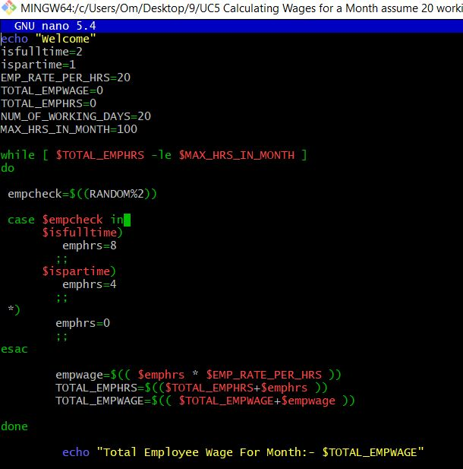

**Output: -**

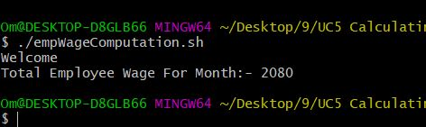

**USECASE 6: - Calculate Wages till a condition of total working hours or days is reached for a month - Assume 100 hours and 20 days**

**Code: -**

isfulltime=2

ispartime=1

EMP_RATE_PER_HRS=20

TOTAL_EMPWAGE=0

TOTAL_EMPHRS=0

NUM_OF_WORKING_DAYS=20

MAX_HRS_IN_MONTH=100

while [ $TOTAL_EMPHRS -le $MAX_HRS_IN_MONTH ]

do

empcheck=$((RANDOM%2))

case $empcheck in

$isfulltime)

emphrs=8

;;

$ispartime)

emphrs=4

;;

*)

emphrs=0

;;

esac

empwage=$(( $emphrs * $EMP_RATE_PER_HRS ))

echo "Daily Wage : $empwage"

TOTAL_EMPHRS=$(($TOTAL_EMPHRS+$emphrs ))

TOTAL_EMPWAGE=$(( $TOTAL_EMPWAGE+$empwage ))

done

echo "Total Employee Wage=$TOTAL_EMPWAGE"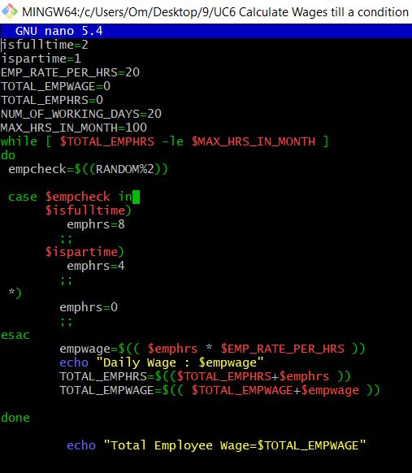

**Output:-**

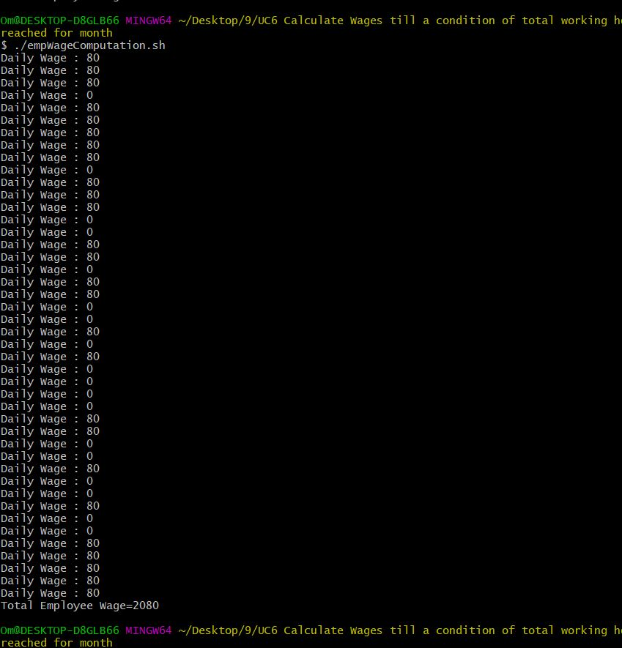

**USW CASE 7: - Refactor the Code to write a function to get work hours**

**Code: -**

#!/bin/bash -x

echo "Welcome"

isPartTime=1

isFullTime=2

maxHrsInMonth=10

empRatePerHr=20

numWorkingDays=20

totalEmpHrs=100

totalWorkingDays=20

function getWorkingHours() {

case $1 in

$isFullTime) workHrs=8 ;;

$isPartTime) workHrs=4 ;;

*) workHrs=0 ;;

esac

echo "Working Hours :" $workHrs

}

while [[ $totalWorkHrs -lt $maxHrsInMonth && $totalWorkingDays -lt $numWokingDays ]]

do

((totalWorkingDays++))

workHrs"$( getWorkingHours $((RANDOM)) )"

totalWorkHrs=$(($totalWorkHrs * $workHrs))

done

totalSalary=$(($totalWorkHrs * $workHrs))

echo "Total Salary:" $totalSalary

**USE CASE 8: - Store the Daily Wage along with the Total Wage**

**Code: -**

isPartTime=1

isFullTime=2

maxHrsInMonth=4

empRatePerHr=20

numWorkingDays=20

totalEmpHrs=4

totalWorkingDays=0

function getWorkHrs() {

local $empCheck=$1

case $empCheck in

$isFullTime) empHrs=8 ;;

$isPartTime) empHrs=4 ;;

*) empHrs=0 ;;

esac

echo $empHrs

}

function getEmpWage() {

local empHr=$1

echo $(($empHr * $empRatePerHr))

}

while [[ $totalEmpHrs -lt $maxHrsInMonth && $totalWorkingDays -lt $numWokingDays ]]

do

((totalWorkingDays++))

empCheck=$((RANDOM%3))

empHrs="$( getWorkingHours $empCheck )"

totalEmpHrs=$(($totalEmpHrs + $empHrs))

dailyWage[$totalWorkingDays]="$( getEmpWage $empHrs )"

done

totalSalary=$(($totalEmpHrs * $empRatePerHr))

echo ${dailyWage[@]}

echo $totalSalary

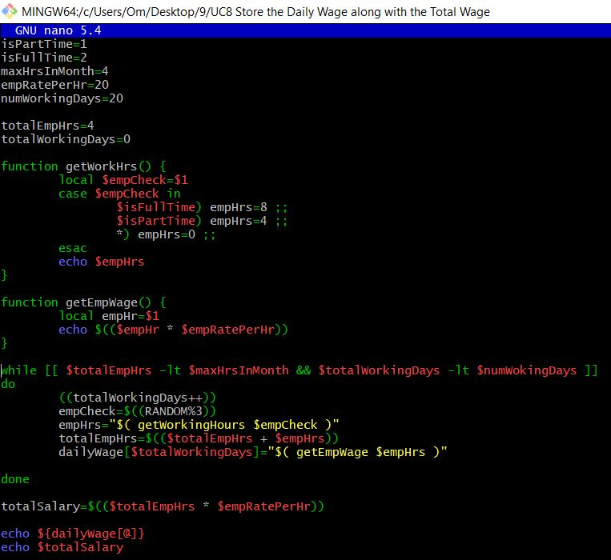

**Output: -**

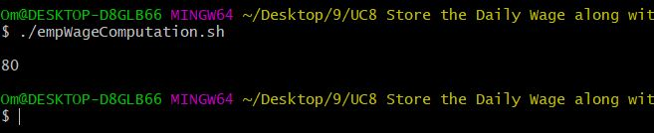

**USE CASE 9: - Store the Day and the Daily Wage along with the Total Wage**

**Code: -**

isPartTime=1

isFullTime=2

maxHrsInMonth=4

empRatePerHr=20

numWorkingDays=20

totalEmpHrs=0

totalWorkingDays=0

declare -A dailyWage

function getWorkHrs() {

local $empCheck=$1

case $empCheck in

$isFullTime) empHrs=8 ;;

$isPartTime) empHrs=4 ;;

*) empHrs=0 ;;

esac

echo $empHrs

}

function getEmpWage() {

local empHr=$1

echo $(($empHr*$empRatePerHr))

}

while [[ $totalEmpHrs -lt $maxHrsInMonth && $totalWorkingDays -lt $numWokingDays ]]

do

((totalWorkingDays++))

empCheck=$((RANDOM%3))

empHrs="$( getWorkingHours $empCheck )"

totalEmpHrs=$(($totalEmpHrs+$empHrs))

dailyWage["Day"$totalWorkingDays]="$( getEmpWage $empHrs )"

done

totalSalary=$(($totalEmpHrs*$empRatePerHr))

echo "${dailyWage[@]}"

echo "${!dailyWage[@]}"